**Lesson 5 Demo 2**

**Removing any Existing Jenkins Plugin**

**Objective:** Remove an already installed Jenkins’s plugin using Plugin Manager.

**Tools required:** Jenkins

**Pre-requisites:** You need to have a Jenkins up and running.

Steps to be followed:

1. Log in to Jenkins CI tool and uninstall an existing unused Jenkins plugin

**Step 1: Log in to Jenkins CI Tool and install Maven Integration plugin**

1. Login to Jenkins CI tool with admin user and install Maven Integration plugin and configure it:
2. Access Plugin manager to and then access Installed Tab to search for a plugin to be uninstalled.

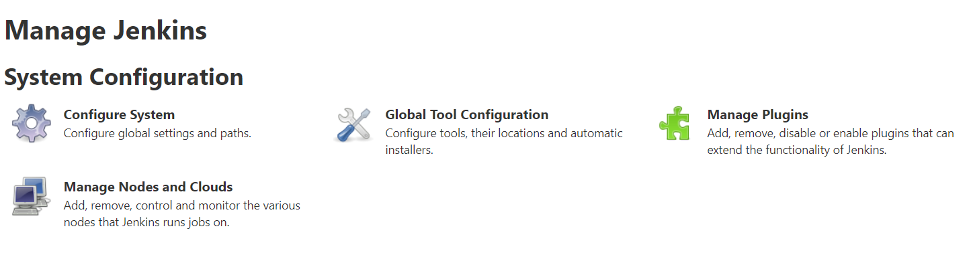

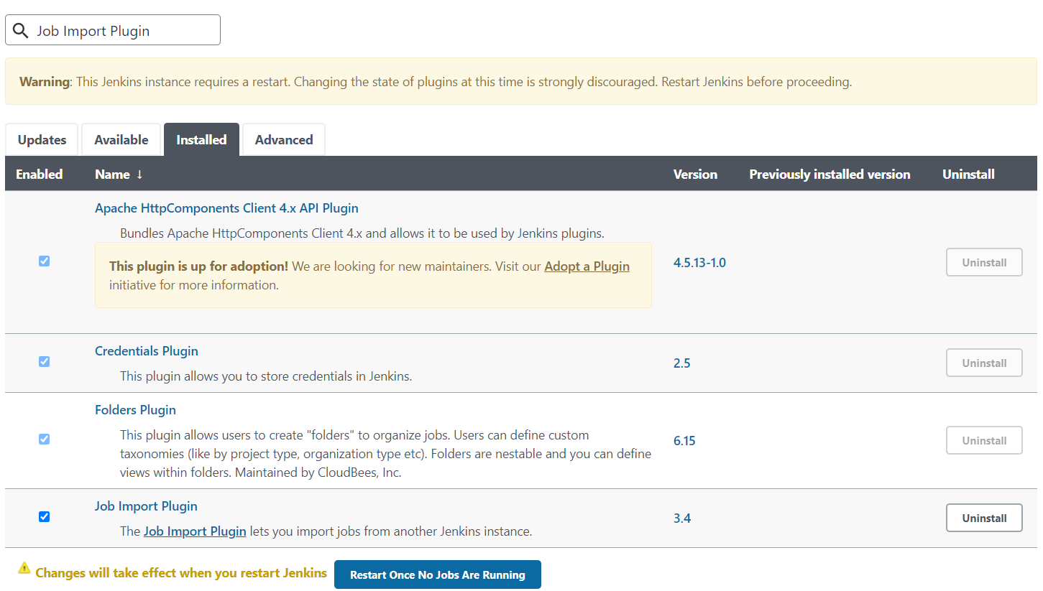

1. Then Click on Uninstall button to remove this installed plugin completely from Jenkins.

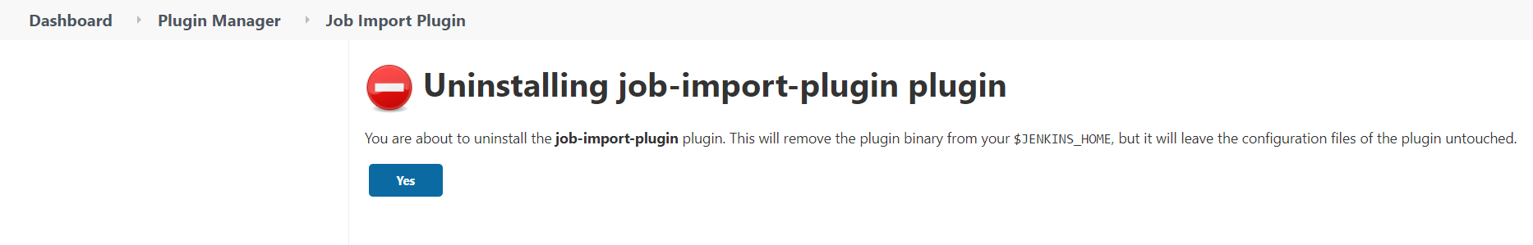

1. Once plugin is uninstalled restart Jenkins to activate plugin in Jenkins.

